Worksheet – Return-to-libc

Q1 Describe the process of return-to-libc attacks. There are four main Tasks, state each task and describe in a few words how you it was implemented?

Q2 Draw the state of the stack frame during the execution of the Function Prologue.

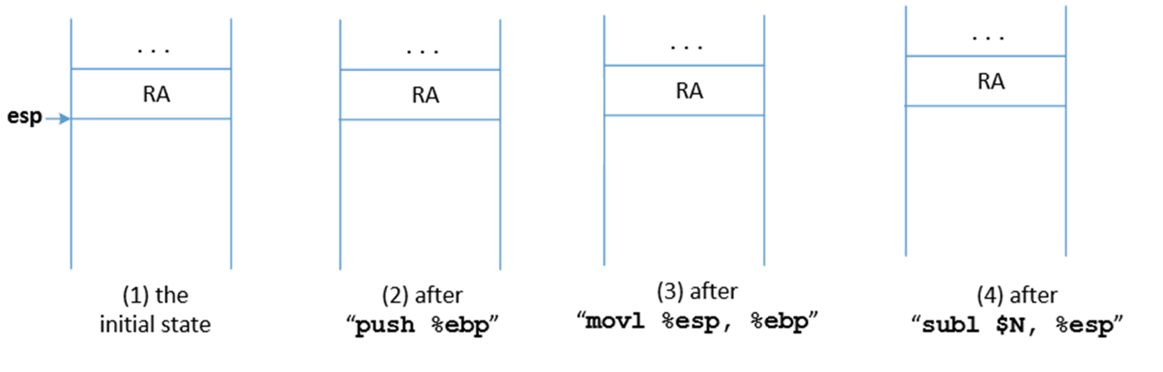
In the initial state the we see that there is a return address pushed to the stack. To what is the return address pointing? (Assuming that there has been no buffer overflow)

Q3 Draw the state of the stack frame during the execution of the Function Epilogue
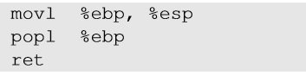
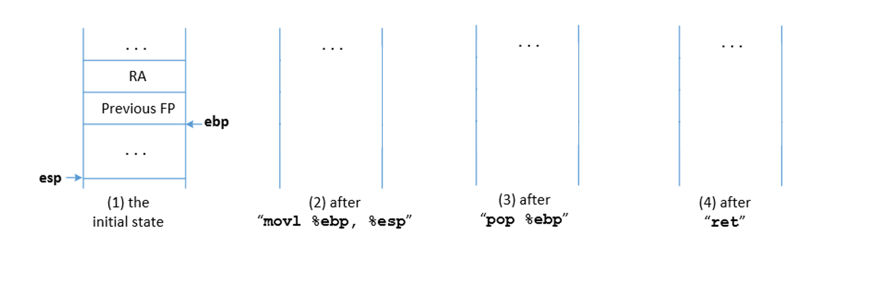

Q4 Fill out the following table with the esp and ebp values. (ebp starting value is X)
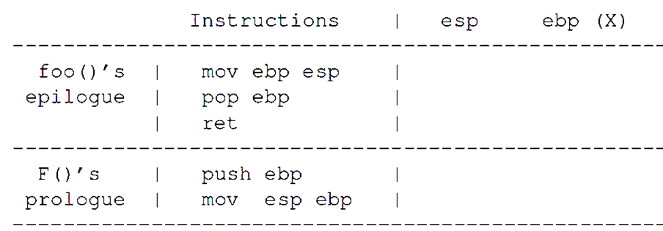

Q6 Assuming ebp address for state (a) is X.
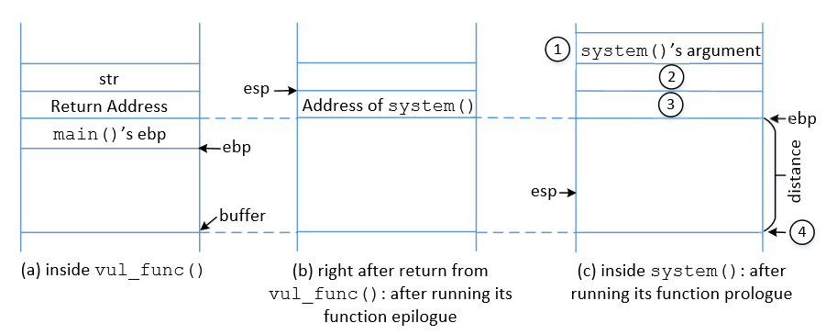
What is the address of epb in state (b)?
What is the address of epb in state (c)?
Where do you store the arguments for system(), relative to epb in state (a) “X” ?
Where do you store the return address for system(), relative to epb in state (a) “X”?

